**A Project Report**

**On**

**Online Course Certification System**

Submitted in partial fulfilment of the requirements for the award of degree of

**Bachelor of Business Administration (Computer Application)**

**Submitted By:**

**A48 Pranav Malwatkar**

**A02 Aaryan Ojha**

**Submitted to:**



Shree Chanakya Education Society

**Indira College of Commerce and Science, Pune**

**Vice Principal & (H.O.D) Guided By**

**Prof. Shivendu Bhushan Prof. Shubhangi Chavan**

**Acknowledgement**

We would like to express our sincere and heartfelt gratitude to our institution” Indira College of Commerce and Science” which provided us with excellent opportunity to achieve our most cherished goal in life to become bachelor’s degree in BBA-CA.

We are extremely grateful to our respected Vice Principal and HOD Prof, Shivendu Bhushan for providing excellent academic environment which has made this endeavor possible.

We take this opportunity to express our deep sense of gratitude to our guide prof. Shubhangi Chavan for their resplendent idea and constant encouragement in making this project unmitigated success. Their thoughtfulness and understanding were vast and thoroughly helpful in successful completion of project. Our sincere thanks to all our faculties and non-teaching staff for them at most co-operation.

Finally, we proudly thank our parents and friends for their constant support and priceless guidance in throughout this endeavor.

Pranav Malwatkar A48

Aaryan Ojha A02

**Index**

|  |  |  |  |
| --- | --- | --- | --- |
| Sr. No |  | Particulars | Page No. |
| 1 |  | Abstract | 1 |
| 2 |  | Introduction | 2-8 |
|  | 2.1 | Motivation | 2 |
|  | 2.2 | Problem statement | 3 |
|  | 2.3 | Purpose/Objectives/goals | 3 |
|  | 2.4 | Literature survey | 4 |
|  | 2.5 | Project Scope and Limitations | 8 |
| 3 |  | System Analysis | 8-13 |
|  | 3.1 | Existing System | 8 |
|  | 3.2 | Scope and Limitation of existing system | 8 |
|  | 3.3 | Project perspective, features, stakeholders | 9 |
|  | 3.4 | Requirement Analysis | 9 |
|  | 3.4.1 | Functional Analysis | 10 |
|  | 3.4.2 | Performance Analysis | 11 |
|  | 3.4.3 | Security Analysis | 13 |
| 4 |  | System Design | 14-20 |
|  | 4.1 | Design constraints | 14-15 |
|  | 4.2 | System Model | 16 |
|  | 4.2.1 | Data Flow Diagram | 17-18 |
|  | 4.2.2 | Data Model | 19-22 |
|  | 4.3 | User Interface | 23-29 |
| 5 |  | Implementation Details | 29 |
|  | 5.1 | Software and hardware specifications | 29 |
| 6 |  | Output and Report Testing | 30-35 |
|  | 6.1 | Test Plan | 30 |
|  | 6.2 | Black Box Testing/Data validations Test cases | 31 |
|  | 6.3 | White Box Testing/functional validations Test cases and results | 32-35 |
| 7 |  | Conclusion and Recommendation | 35 |
| 8 |  | Future Scope | 35 |
| 9 |  | Bibliography and References | ss36 |

**1)Abstract:**

The Online Course Certificate represents a significant milestone in modern education, embracing the power of digital learning to provide accessible, flexible, and high-quality educational experiences. This certificate is a testament to the successful completion of an online course, showcasing a commitment to continuous learning and skill development in the digital age.

The Online Course Certificate signifies more than just the acquisition of information; it symbolizes adaptability and resilience in an ever-evolving world. It is a testament to the ability to harness the internet's vast resources to gain expertise, enrich personal and professional growth, and stay competitive in a rapidly changing global landscape.

This certificate is a valuable recognition of one's commitment to lifelong learning, self-improvement, and the pursuit of excellence. It represents the bridging of geographical, temporal, and logistical barriers that once hindered education, offering an opportunity for individuals to learn, grow, and excel on their own terms.

The Online Course Certificate serves as a tangible demonstration of the recipient's dedication to self-improvement and knowledge acquisition in the digital age, making it a valuable asset for personal and professional development. It signifies a commitment to continuous learning and adaptability, attributes highly sought after in today's fast-paced and knowledge-driven society.

**2) Introduction:**

Discover the Future of Learning with “SkillNinja” Online Course Certification System. Education transcends traditional boundaries on our platform, where dynamic online courses meet personalized certification pathways. Immerse yourself in engaging content curated by experts, designed to equip you with practical skills applicable to real-world scenarios. As you complete courses, watch your knowledge evolve and gain the confidence to thrive in your chosen field. Our globally recognized certifications validate your accomplishments, signalling your expertise to employers and peers alike. Join us in reshaping education - dive into a new era of knowledge acquisition with the Online Course Certification System.

**2.1) Motivation:**

Embarking on the journey to earn your Online Course Certificate is a remarkable endeavor. It signifies your commitment to personal and professional growth, and the documentation of this journey will serve as a testament to your dedication. As you work through the course material, remember that each step you take brings you closer to your goals. Celebrate every small win, and when faced with challenges, view them as opportunities to learn and improve. The journey might have its ups and downs, but it's these experiences that shape your knowledge and skills. Visualize the day you hold your Online Course Certificate, a symbol of your hard-earned expertise, and let that image inspire and motivate you to persevere. Your dedication to continuous learning and self-improvement will open doors to new opportunities and achievements, making the documentation of this journey a valuable record of your success.

**2.2 Problem Statement:**

The notable crime reporting platforms are lopsided and not intuitive. The process of reporting crimes to security agencies still remains very difficult. The platforms are also undirectional in the sense that they do not have feedbacks for member of society. The existing platform do not support sharing of relevant information with other security agencies, thereby because owners of this platforms want to take all praise; while in actual fact security is being reinforced when meaningful and relevant information is shared among security stakeholders towards offering an excellent service.

**2.3 Purpose/Objectives/Goals:**

The proposed system aims to address the limitations of the existing online Course Certification System by introducing innovative features and improvements to enhance the learning experience. By making it cost-effective and providing a user-friendly interface we aim to achieve all the requirements that are necessary.

**2.4 Literature Survey:**

In the realm of online education, the surge in demand for online learning and the pursuit of certifications has paved the way for the development of Online Course Certification Systems. This literature survey delves into the extensive body of research and industry practices surrounding these systems, providing a comprehensive overview of their current state. It begins by acknowledging the growing prevalence of online learning, as observed by scholars like Allen and Seaman (2017), who have noted the increasing number of online learners. This growth has elevated the significance of certification and accreditation, as emphasized by Hu and Ganesan (2019), in establishing the credibility of online courses.

Key features of Online Course Certification Systems are explored, encompassing components such as course management, user registration, assessment tools, and certificate generation. These systems often rely on Learning Management Systems (LMS), as articulated by Khan and Farooq (2019), underscoring the integration of certification capabilities.

Ensuring the quality and integrity of online certifications poses a fundamental challenge. Scholars like Legault et al. (2018) have investigated strategies to counter issues like cheating and plagiarism in online assessments. Quality assurance and accreditation frameworks, as endorsed by organizations like Quality Matters (Walters, 2020), have emerged to address these concerns.

User experience and accessibility are also vital aspects of these systems. Anderson (2019) underscores the importance of user-friendly interfaces, accessibility features, and support services, while studies suggest that mobile compatibility is essential to reach a broader audience (Zawacki-Richter et al., 2019).

The survey further explores industry practices, drawing insights from leading e-learning platforms such as Coursera, edX, and Udemy, which have implemented their own Online Course Certification Systems. The models and practices employed by these platforms offer valuable insights for research and serve as real-world examples of successful commercial solutions (Simon et al., 2021).

In conclusion, this literature survey paints a comprehensive picture of the Online Course Certification System landscape, highlighting their increasing importance in the context of online education. It sheds light on challenges related to quality assurance, user experience, and accessibility, while also gleaning wisdom from industry practices to inspire the development and enhancement of Online Course Certification Systems in the proposed project.

**2.5 Project Scope and Limitations:**

The proposed system aims to address the limitations of the existing online Course Certification System by introducing innovative features and improvements to enhance the learning experience. By making it cost-effective and providing a user-friendly interface we aim to achieve all the requirements that are necessary. The only limitations this system has that it has less resources as of now and we do not have proper certification authority.

**3) System Analysis:**

**3.1) Existing System:**

The existing Course Certification System involves a manual and paper-based process for managing and awarding course certifications. Students participate in various educational courses and upon completion, their progress and achievements are recorded on paper documents. These documents then undergo a verification process by administrators, involving cross-referencing with course records and grading criteria. Once verified, certificates are manually generated, printed, and distributed to the students. This system is time-consuming, prone to errors, and lacks efficiency in terms of data management and retrieval. Most of the courses and certification providing system available online are paid and require a specific amount to be paid.

**3.2) Scope and Limitations of Existing System:**

1. The system relies heavily on manual data entry, verification, and certificate generation, leading to inefficiencies, errors, and delays.

2. The manual nature of the process makes it time-consuming, as administrators need to cross-reference records, verify completion, and generate certificates individually.

3. Many online courses focus on theoretical concepts, which may not effectively translate into practical skills without hands-on experiences and real-world applications.

4. Many online available courses are paid and not very cost effective, hence it is difficult for some users to get their certifications.

**3.3) Project perspective, features, stakeholders:**

**Features:**

* User: -
* Registration & Login
* Browse Courses
* Profile Update
* Enroll for Courses
* Learning & Certification
* Admin: -
* Login
* Adding Courses
* Manage Courses
* Issue Certificates

**Stakeholders:**

There are only 2 main figures in this Online Course Certification System: User and Admin. User reports the Creates their account and watches the course of their choice. Meanwhile Admin monitors the user activity and provides them with the Certificate once the Course is completed. Admin also adds new courses to the system.

**3.4) Requirement Analysis:**

Requirements Analysis is the process of defining the users’ expectations for an application to be built or modified. Requirement’s analysis involves all the tasks that are conducted to identify the needs of different stakeholders. Therefore, requirements analysis means analyzing, documenting, validating, and managing software or system requirements. As the software system requirements were predictable, wallowing the classical system development life cycle method is decided. This process demands a systematic, sequential approach to software development that begins at the system level and progress through analysis, design, coding, testing and maintenance. The steps that apply to all software engineering paradigms. The program is followed by SDLC (Software Development Life Cycle).

**3.4.1) Functional Analysis:**

Functional analysis: a method for conceptualizing systems [with an application to the ATC system] Functional analysis is a method for examining a system's purpose and performance requirements and translating them into distinct activities or tasks that the system must do.

**3.4.2) Performance Analysis:**

The success or failure of a project is measured using numerous metrics in a performance analysis. It aids in the development of a positive project management culture that produces exceptional results. A good program's performance usually necessitates appropriate stakeholder management.

Following is chart that describes our web-based project performance over the available devices:

**3.4.3) Security Analysis:**

In the existing system, storage of all these records should be arranged and security should be provided for the records. In the proposed system, separate security arrangement is not needed since the software provides security and maintenance is simply and hardly needs one or two people to operate the system.

**4) System Design:**

**4.1) Design Constraints:**

**A) ERD**

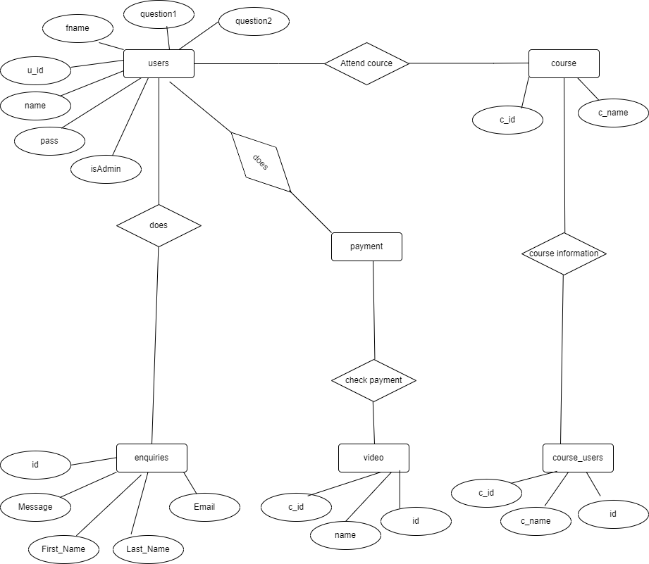

**4.2) Data Flow Diagram:**

Online Course system

Admin

Admin

User

User

**0.0**

Query

Report

Access

Response Details

Acknowledgement

Login

Course Details

Payment

**4) First Level DFD:**

Master

Generation

Process

Admin

**1.0**

User Details

Select Course

Payment Details

Course Details

Course

User Details

User

Payment

Search

Enq

uiry

Process

**3.0**

Admin

User

Query

System Details

g

Lo

in

Process

Admin

**2.0**

Username

and Password

Access

Login

User

User

Username

and Password

Access

Username

and Password

Username

and Password

Certificate

Process

**4.0**

Certificate

User

Login and payment

Video watch

Select course

User

**5.0**

Course

Payment

Course

Details

Payment

Payment

Details

Payment

Acknowledgement

Payment

Process

Admin

**6.0**

Login

Details

Query

Report

Certificate

Generation

Process

Login

Enroll

Payment

Enquiry

Course

Details

Payment

Details

Enquiry

Details

**4.2.2) Data Model:**

**A) Class Diagram:**

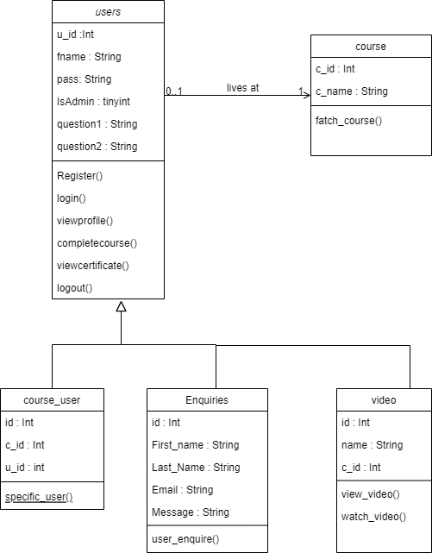

**B) Object Diagram:**

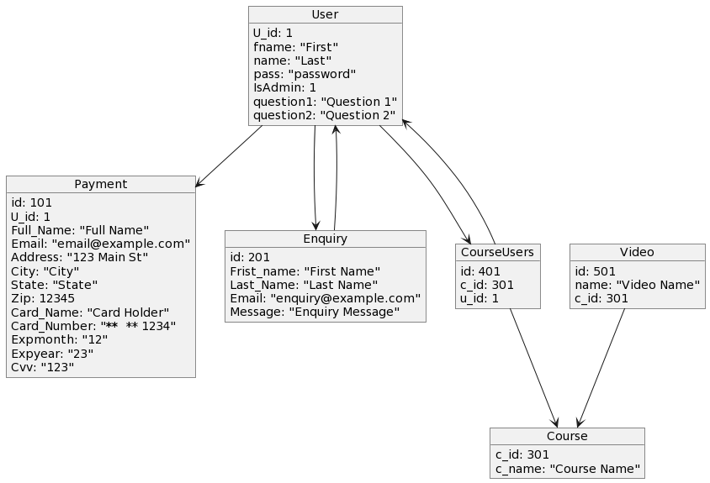

**C) Use Case Diagram:**

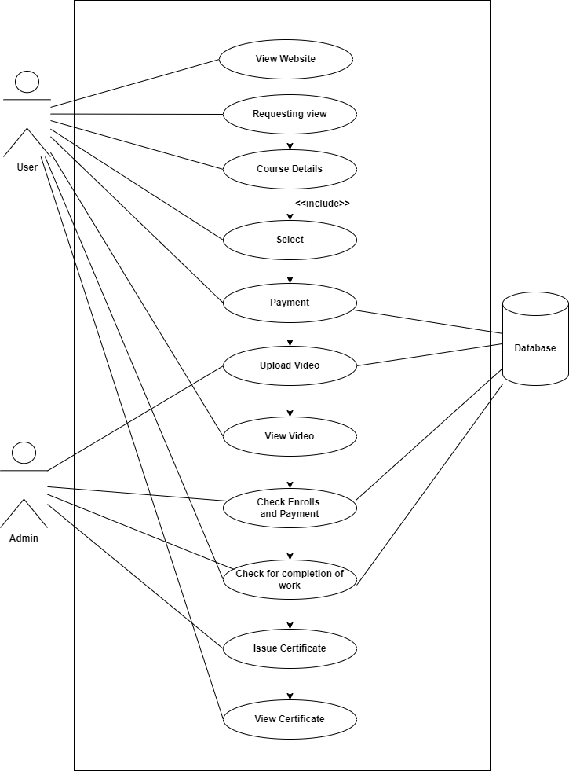

**I) Sequence Diagram:**

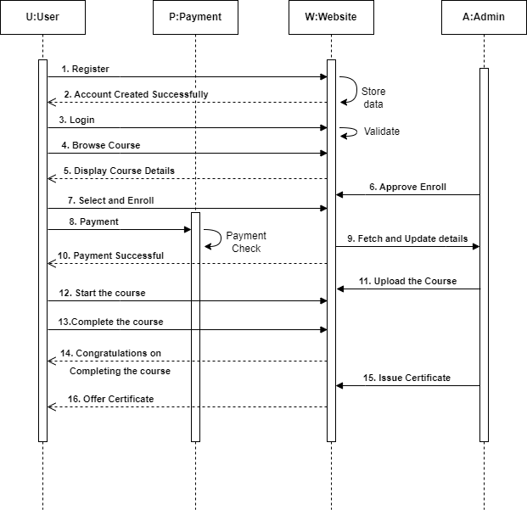

**D) Activity Diagram:**

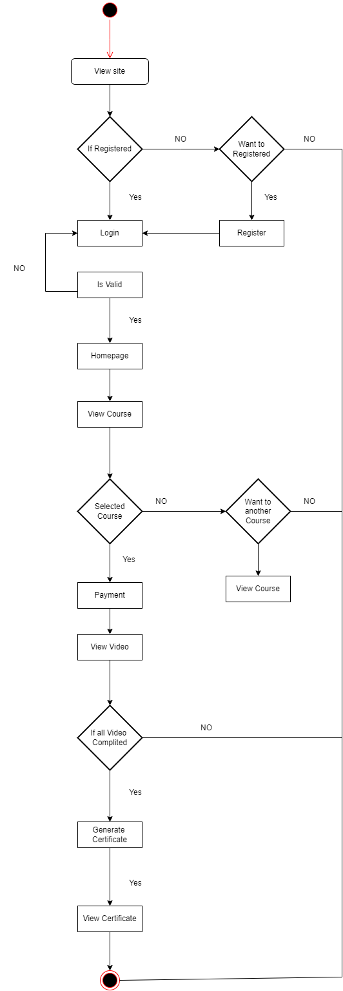

**E) Deployment Diagram:**

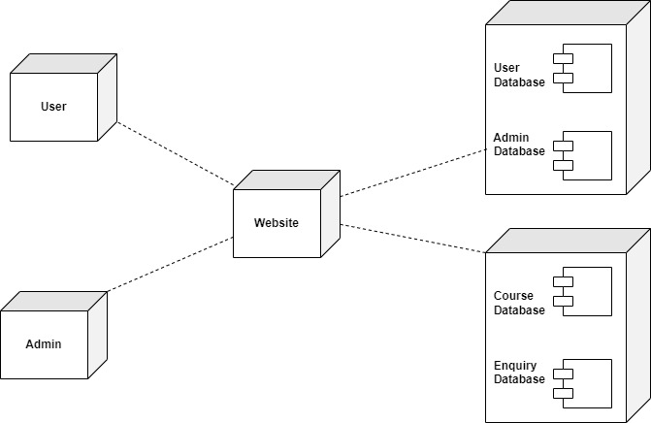

**G) Component Diagram:**

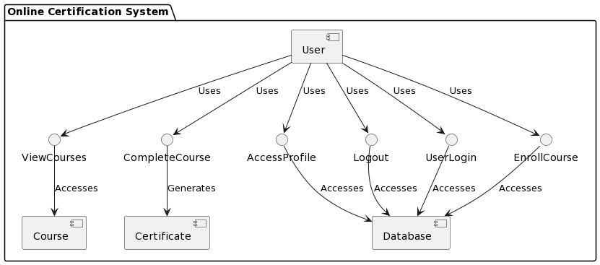

**H) State Chart Diagram:**

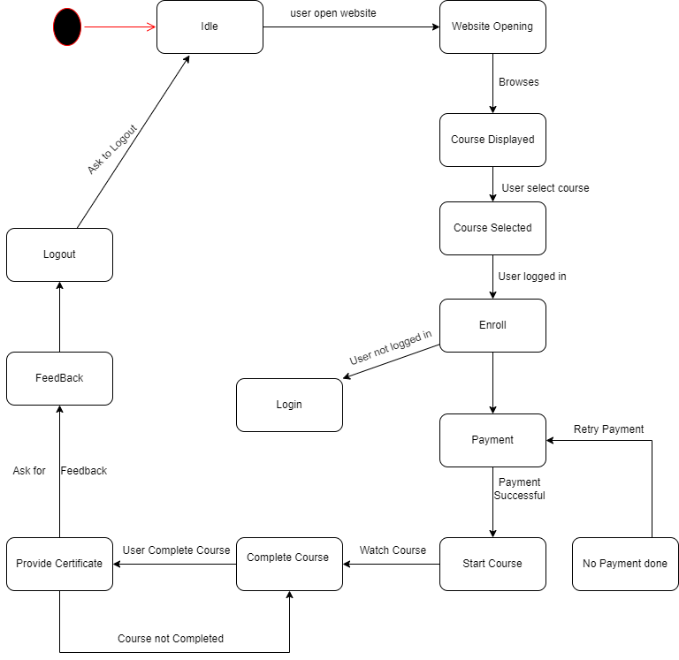

**4.2.2) File Design / Normalized Database :**

**Table Name – users**

|  |  |  |  |  |
| --- | --- | --- | --- | --- |
| **Sr No.** | **Field Name** | **Datatype** | **Width** | **Constraint** |
| 1 | U_id | INT | 99 | Primary Key |
| 2 | fname | VARCHAR | 25 | Not Null |
| 3 | name | VARCHAR | 25 | Not Null |
| 4 | pass | VARCHAR | 25 | Not Null |
| 5 | IsAdmin | TINYINT | 1 | Not Null |
| 5 | question1 | VARCHAR | 66 | Not Null |
| 6 | question2 | VARCHAR | 66 | Not Null |

**Table Name –payment**

|  |  |  |  |  |
| --- | --- | --- | --- | --- |
| **Sr No.** | **Field Name** | **Datatype** | **Width** | **Constraint** |
| 1 | id | INT | 99 | Primary Key |
| 2 | U_id | INT | 99 | Not Null |
| 3 | Full_Name | VARCHAR | 35 | Not Null |
| 4 | Email | VARCHAR | 35 | Not Null |
| 5 | Address | VARCHAR | 35 | Not Null |
| 6 | City | VARCHAR | 35 | Not Null |
| 7 | State | VARCHAR | 35 | Not Null |
| 8 | Zip | INT | 35 | Not Null |
| 9 | Card_Name | VARCHAR | 35 | Not Null |
| 10 | Card_Number | VARCHAR | 35 | Not Null |
| 11 | Expmonth | VARCHAR | 35 | Not Null |
| 12 | Expyear | VARCHAR | 35 | Not Null |
| 13 | Cvv | VARCHAR | 35 | Not Null |

**Table Name –enquiries**

|  |  |  |  |  |
| --- | --- | --- | --- | --- |
| **Sr No.** | **Field Name** | **Datatype** | **Width** | **Constraint** |
| 1 | id | INT | 4 | Primary Key |
| 2 | Frist_name | VARCHAR | 35 | Not Null |
| 3 | Last_Name | VARCHAR | 35 | Not Null |
| 4 | Email | VARCHAR | 35 | Not Null |
| 5 | Message | VARCHAR | 35 | Not Null |

**Table Name –course**

|  |  |  |  |  |
| --- | --- | --- | --- | --- |
| **Sr No.** | **Field Name** | **Datatype** | **Width** | **Constraint** |
| 1 | c_id | INT | 99 | Primary Key |
| 2 | c_name | VARCHAR | 99 | Not Null |

**Table Name –course_users**

|  |  |  |  |  |
| --- | --- | --- | --- | --- |
| **Sr No.** | **Field Name** | **Datatype** | **Width** | **Constraint** |
| 1 | id | INT | 99 | Primary Key |
| 2 | c_id | INT | 99 | Not Null |
| 3 | u_id | INT | 99 | Not Null |

**Table Name –video**

|  |  |  |  |  |
| --- | --- | --- | --- | --- |
| **Sr No.** | **Field Name** | **Datatype** | **Width** | **Constraint** |
| 1 | id | INT | 99 | Primary Key |
| 2 | name | INT | 99 | Not Null |
| 3 | c_id | INT | 99 | Not Null |

**Data Dictionary :**

|  |  |  |  |  |  |  |
| --- | --- | --- | --- | --- | --- | --- |
| **Sr. No.** | **Field Name** | **Data**  **type** | **Width** | **Constraint** | **Table Name** | **Data Description** |
| 1 | u_id | int | 33 | Primary key | users | User id |
| 2 | fname | Varchar | 33 | Not null | users | Full Name |
| 3 | pass | Varchar | 33 | Not null | users | User Password |
| 4 | IsAdmin | Tinyint | 33 | Not null | users | Admin check |
| 5 | question1 | Varchar | 99 | Not null | users | College Name |
| 6 | question2 | Varchar | 99 | Not null | users | Mother Name |
| 7 | id | int | 99 | Primary key | payment | Payment id |
| 8 | u_id | int | 99 | Not null | payment | User id |
| 9 | Full_Name | Varchar | 33 | Not null | payment | Card Details |
| 10 | Email | Varchar | 33 | Not null | payment | Card Details |
| 11 | Address | Varchar | 33 | Not null | payment | Card Details |
| 12 | City | Varchar | 33 | Not null | payment | Card Details |
| 13 | State | Varchar | 33 | Not null | payment | Card Details |
| 14 | Zip | Varchar | 6 | Not null | payment | Card Details |
| 15 | Card_Name | Varchar | 33 | Not null | payment | Card Details |
| 16 | Card_Number | Int | 33 | Not null | payment | Card Details |
| 17 | Expmonth | Int | 2 | Not null | payment | Card Details |
| 18 | Expyear | Int | 4 | Not null | payment | Card Details |
| 19 | Cvv | Int | 3 | Not null | payment | Card Details |
| 20 | id | Int | 99 | Primary key | enquiries | Enquiries Details |
| 21 | Frist_name | Varchar | 35 | Not null | enquiries | Enquiries Details |
| 22 | Last_Name | Varchar | 35 | Not null | enquiries | Enquiries Details |
| 23 | Email | Varchar | 35 | Not null | enquiries | Enquiries Details |
| 24 | Message | Varchar | 35 | Not null | enquiries | Enquiries Details |
| 25 | c_id | Varchar | 99 | Primary key | course | Course id |
| 26 | c_name | Varchar | 90 | Not null | course | Course names |
| 27 | id | Int | 99 | Primary key | course_users | Course User id |
| 28 | c_id | Int | 99 | Not null | course_users | Course id |
| 29 | u_id | Int | 99 | Not null | course_users | User id |
| 30 | id | Int | 99 | Primary key | video | Video id |
| 31 | name | Varchar | 99 | Not null | video | Video Name |
| 32 | c_id | Int | 99 | Not null | video | Course id |

**4.3) User Interface**



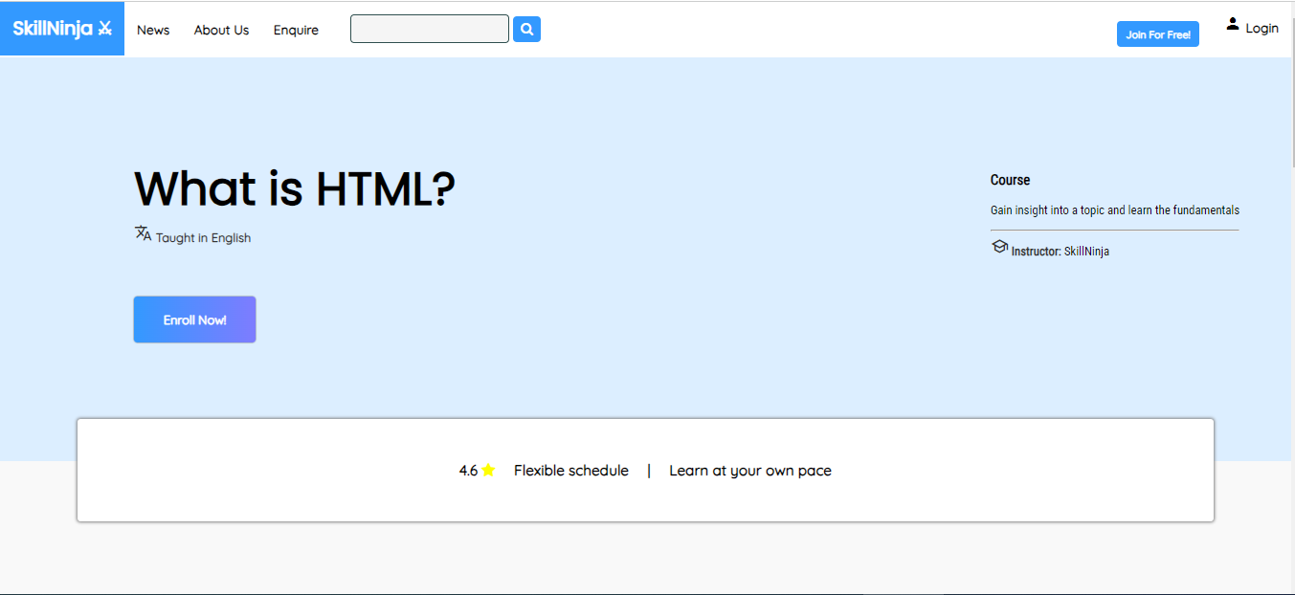

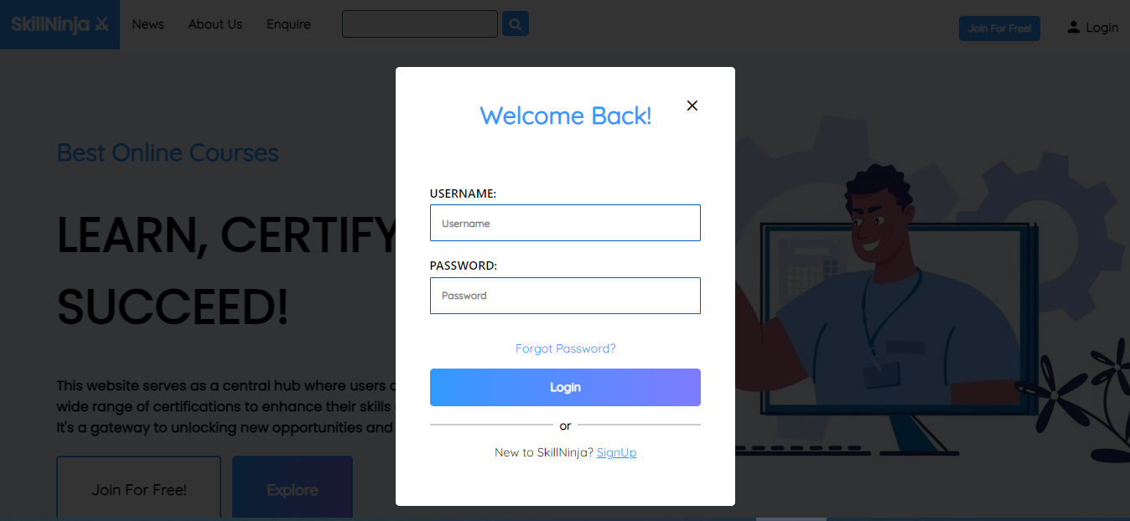

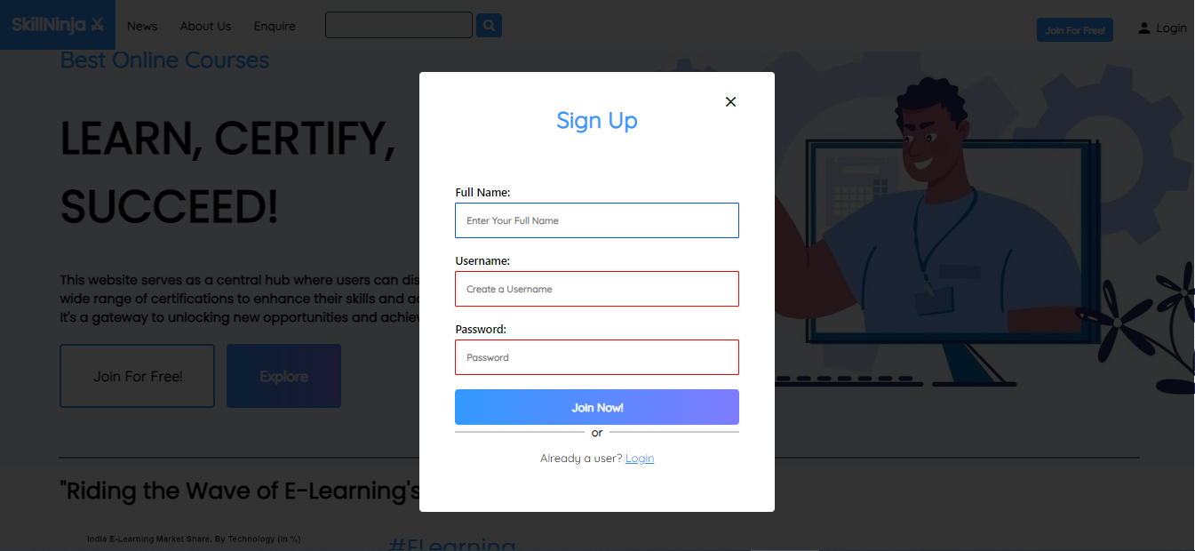

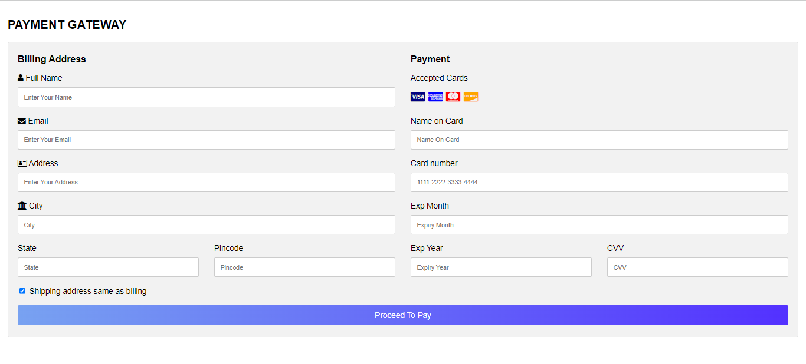

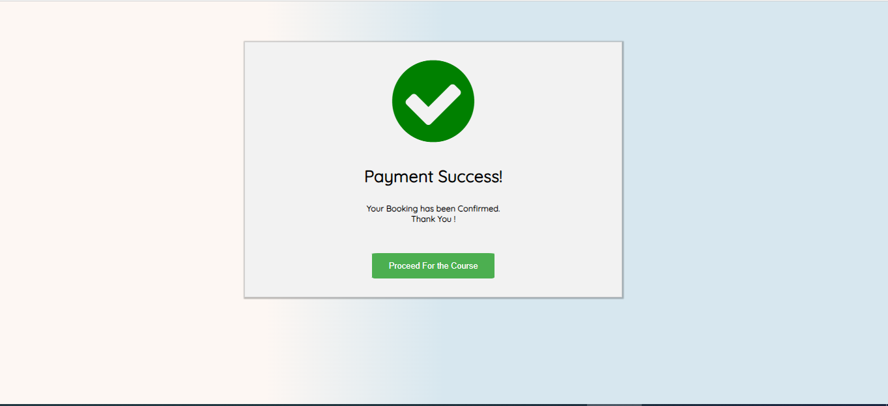

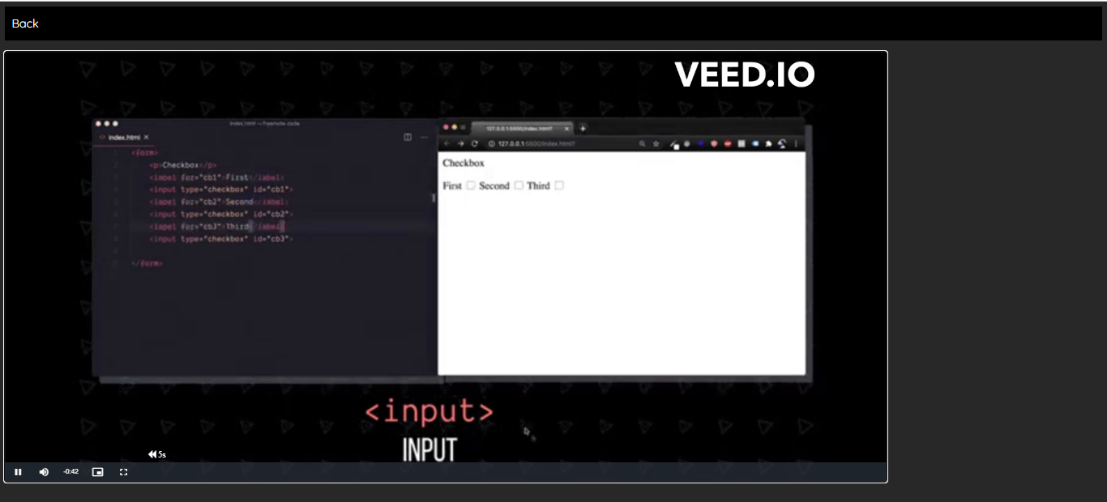

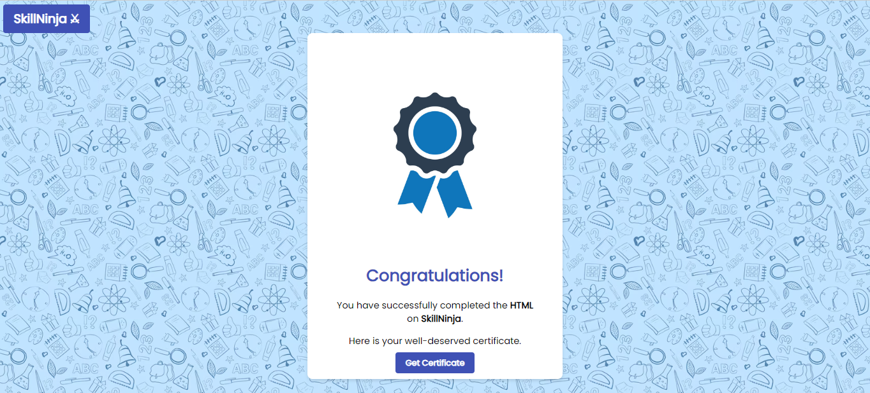

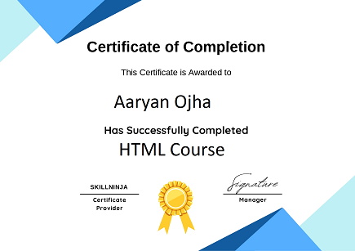

**Code :**

**Index.php**

<html>

<head>

  <meta name="viewport" content="width=device-width, initial-scale=1.0" />

  <link rel="stylesheet" href="https://cdnjs.cloudflare.com/ajax/libs/font-awesome/4.7.0/css/font-awesome.min.css" />

  <link href="https://fonts.googleapis.com/icon?family=Material+Icons" rel="stylesheet" />

  <link href="https://fonts.googleapis.com/icon?family=Material+Icons" rel="stylesheet">

  <link rel="stylesheet" href="style.css" />

  <script src="script.js"></script>

</head>

<body>

  <div class="topnav" id="myTopnav">

    <a href="#home" class="active">SkillNinja ⚔︎</a>

    <a href="#home" class="" style="padding-top: 1.5%">News</a>

    <a href="aboutus.php" class="" style="padding-top: 1.5%">About Us</a>

    <a href="enquire.php" class="" style="padding-top: 1.5%">Enquire</a>

    <!-- <a style="pointer-events:none;float:right"> &emsp;</a> -->

    <div>

  </div>

    <!-- <a href="#home" class="" style="float: right; padding-top: 1.5%" onclick="openform()">Login &emsp;</a> -->

    <?php

    // Check if the user is logged in

    session_start();

    if (isset($_SESSION['username'])) {

      // If logged in, show the username and a logout button

      // echo "Welcome, " . $_SESSION['username'] . "!";

      echo '  <div class="dropdown">

    <button class="dropbtn">

      <img src="../Images/user.png" style="zoom:8%">&emsp;&emsp;

    </button>

    <div class="dropdown-content">

      <a>Signed in as <b>' .$_SESSION['username'].'</b></a>

      <hr>

      <a href="profile.php"><i class="material-icons">person</i> Profile</a>

      <a href="logout.php"><i class="fa fa-sign-out"></i> Logout</a>

    </div>

  </div> ';

    } else { // If not logged in, show the login form

      echo '<a href="#" onclick="openform()" style="float:right;padding-top: 1%;"><i class="material-icons">person</i> Login</a>';

    } ?>

    <?php

    if (!isset($_SESSION['username'])) { ?>

      <a href="#home" class="" style="float: right; padding-top: 1.5%" onclick="openform2()"><button id="reg-btn"

          style="pointer-events: none">

          Join For Free!

        </button></a>

    <?php } ?>

    <a href="#none" style="padding-top: 1%">&nbsp;<input type="search" name="" id="" class="search-bar" />&nbsp;<i

        id="search-btn" class="fa fa-search"></i></a>

    <a href="javascript:void(0)" class="icon" onclick="myFunction()"><i class="fa fa-bars"></i></a>

  </div>

  <!-- Login -->

  <div class="form-popup" id="myform">

    <div class="form-container">

      <h1>Welcome Back!</h1>

      <a href="#closebtn" class="closebtn" onclick="closeform()"><i class="material-icons">close</i></a>

      <form action="../Database/logindb.php" method="POST">

        <label for="username">USERNAME:</label>

        <input type="text" name="uname" id="" placeholder="Username" />

        <label for="password">PASSWORD:</label>

        <input type="password" name="pass" placeholder="Password" />

        <p>

          <a href="#forgotpass" style="text-decoration: none">Forgot Password?</a>

        </p>

        <button type="submit" name="login" value="login">Login</button>

      </form>

      <hr style="

              width: 45%;

              float: left;

              border: 1px solid rgb(204, 204, 204);

            " />

      <b>or</b>

      <hr style="

              width: 45%;

              float: right;

              border: 1px solid rgb(204, 204, 204);

            " />

      <p>

        New to SkillNinja?

        <a href="#home" onclick="openform2(),closeform()">SignUp</a>

      </p>

    </div>

  </div>

  <form action="../Database/registerdb.php" method="POST">

    <!-- Register -->

    <div class="form-popup" id="myform2" style="display: none">

      <div class="form-container">

        <h1>Sign Up</h1>

        <a href="#closebtn" class="closebtn" onclick="closeform2()"><i class="material-icons">close</i></a>

        <label for="Fullname">Full Name:</label>

        <input type="text" name="fullname" id="" placeholder="Enter Your Full Name" />

        <label for="username1">Username:</label>

        <input type="text" id="username" required pattern="[a-z]{4,8}[0-9][0-9]{1,9}?" min="0" max="99"

          oninvalid="this.setCustomValidity('Username must be a combination lowercase alphabets and numbers only!')"

          maxlength="12" name="username" id="" placeholder="Create a Username" />

        <label for="password1">Password:</label>

        <input type="password" name="password" id="password" required pattern="[a-z]{4,8}[0-9][0-9]{1,9}?"

          oninvalid="this.setCustomValidity('Password must contain atleast 4 alphabets and a number!')" maxlength="12"

          placeholder="Password" />

        <button type="submit" name="signup">Join Now!</button>

        <hr style="

              width: 45%;

              float: left;

              border: 1px solid rgb(204, 204, 204);

            " />

        <b>or</b>

        <hr style="

              width: 45%;

              float: right;

              border: 1px solid rgb(204, 204, 204);

            " />

        <p>

          Already a user?

          <a href="#home" onclick="openform(),closeform2()">Login</a>

        </p>

      </div>

    </div>

  </form>

  <div class="headers">

    <p>Best Online Courses</p>

    <h1 style="animation: 0.5s ease-out 0s 1 textanim">

      LEARN, CERTIFY,<br />

      SUCCEED!

    </h1>

    <h4 style="animation: 1s ease-out 0s 1 textanim; font-size: large">

      This website serves as a central hub where users can discover, access,

      and pursue a <br />

      wide range of certifications to enhance their skills and advance their

      careers.<br />

      It's a gateway to unlocking new opportunities and achieving personal and

      professional growth.

    </h4>

    <!-- Join For Free! -->

    <?php

    if (!isset($_SESSION['username'])) { ?>

      <button class="centerbtn" style="animation: 1.5s ease-out 0s 1 textanim" onclick="openform2()">Join For Free!

      <?php } else {

      echo "Welcome, <br>" . $_SESSION['username'] . " !"; ?>

      </button>

    <?php } ?>

    <a href="#mycourses">

      <button class="centerbtn2" style="animation: 1.5s ease-out 0s 1 textanim">

        Explore

      </button></a>

  </div>

  <br /><br /><br />

  <hr style="width: 90%; border: 1px solid gray" />

  <div>

    <h1 id="middle-section">

      "Riding the Wave of E-Learning's Popularity Surge!"

    </h1>

    <img src="../Images/graph2.png" alt="" class="graph-img" />

    <p id="middle-section">

      <h7 style="color: #3399ff">#ELearning</h7>

    </p>

    <p style="

          font-family: 'Quicksand', sans-serif;

          font-size: 22px;

          padding: 0% 4% 4% 4%;

        ">

      Amidst a digital revolution, E-learning rides an exhilarating wave of

      popularity. Its accessible and flexible approach to education transcends

      borders, allowing learners to ride the wave of learning on their own

      terms.

    </p>

  </div>

  <hr style="width: 90%; border: 1px solid gray" />

  <div class="courses" id="mycourses">

    <h1 style="font-family: 'Poppins', sans-serif; color: #3399ff">

      OUR COURSES

    </h1>

    <div class="courses">

      <p>Basic</p>

      <h1>Web-Development</h1>

      <div class="course-card">

        <a href="../Courses/html.php" style="text-decoration: none; color: #3399ff"><img src="../Images/html.png" alt=""

            style="zoom: 19.8%" />

          <p style="float: right">

            4.6

            <span class="fa fa-star checked"></span>

            <span class="fa fa-star checked"></span>

            <span class="fa fa-star checked"></span>

            <span class="fa fa-star checked"></span>

            <span class="fa fa-star-half-empty"></span>

          </p>

          <hr />

          Learn HTML

          <p style="

                font-size: medium;

                color: black;

                font-family: 'Quicksand', sans-serif;

              ">

            Start at the beginning by learning HTML basics - an important

            <br />foundation for building and editing web pages.

          </p>

        </a>

      </div>

      <div class="course-card">

        <a href="#html" style="text-decoration: none; color: #3399ff"><img src="../Images/css.png" alt=""

            style="zoom: 18%" />

          <p style="float: right">

            4.5

            <span class="fa fa-star checked"></span>

            <span class="fa fa-star checked"></span>

            <span class="fa fa-star checked"></span>

            <span class="fa fa-star checked"></span>

            <span class="fa fa-star-o"></span>

          </p>

          <hr />

          Learn CSS

          <p style="

                font-size: medium;

                color: black;

                font-family: 'Quicksand', sans-serif;

              ">

            In this CSS tutorial, you'll learn how to add CSS to visually<br />

            transform HTML into eye-catching sites.

          </p>

        </a>

      </div>

      <div class="course-card">

        <a href="#html" style="text-decoration: none; color: #3399ff"><img src="../Images/js2.png" alt=""

            style="zoom: 40%" />

          <p style="float: right">

            4.4

            <span class="fa fa-star checked"></span>

            <span class="fa fa-star checked"></span>

            <span class="fa fa-star checked"></span>

            <span class="fa fa-star checked"></span>

            <span class="fa fa-star-o"></span>

          </p>

          <hr />

          Learn Javascript

          <p style="

                font-size: medium;

                color: black;

                font-family: 'Quicksand', sans-serif;

              ">

            Learn how to use JavaScript - a powerful and flexible<br />

            programming language for adding website interactivity.

          </p>

        </a>

      </div>

    </div>

    <div class="courses">

      <p>Intermediate</p>

      <h1>Programming Languages</h1>

      <div class="course-card">

        <a href="#html" style="text-decoration: none; color: #3399ff"><img src="../Images/c.png" alt=""

            style="zoom: 30.5%" />

          <p style="float: right">

            4.8

            <span class="fa fa-star checked"></span>

            <span class="fa fa-star checked"></span>

            <span class="fa fa-star checked"></span>

            <span class="fa fa-star checked"></span>

            <span class="fa fa-star-half-empty"></span>

          </p>

          <hr />

          Learn C

          <p style="

                font-size: medium;

                color: black;

                font-family: 'Quicksand', sans-serif;

              ">

            Learn about the C programming language in this beginner-<br />friendly

            skill path.

          </p>

        </a>

      </div>

      <div class="course-card">

        <a href="#html" style="text-decoration: none; color: #3399ff"><img src="../Images/php.png" alt=""

            style="zoom: 40%" />

          <p style="float: right">

            4.4

            <span class="fa fa-star checked"></span>

            <span class="fa fa-star checked"></span>

            <span class="fa fa-star checked"></span>

            <span class="fa fa-star checked"></span>

            <span class="fa fa-star-o"></span>

          </p>

          <hr />

          Learn PHP

          <p style="

                font-size: medium;

                color: black;

                font-family: 'Quicksand', sans-serif;

              ">

            Learn the fundamentals of PHP, one of the most popular<br />

            languages of modern web development.

          </p>

        </a>

      </div>

      <div class="course-card">

        <a href="#html" style="text-decoration: none; color: #3399ff"><img src="../Images/sql.png" alt=""

            style="zoom: 36%" />

          <p style="float: right">

            4.5

            <span class="fa fa-star checked"></span>

            <span class="fa fa-star checked"></span>

            <span class="fa fa-star checked"></span>

            <span class="fa fa-star checked"></span>

            <span class="fa fa-star-o"></span>

          </p>

          <hr />

          Learn SQL

          <p style="

                font-size: medium;

                color: black;

                font-family: 'Quicksand', sans-serif;

              ">

            In this SQL course, you'll learn how to manage large

            <br />datasets and analyze real data using the standard data

            <br />management language.

          </p>

        </a>

      </div>

    </div>

    <div class="courses">

      <p>Advanced</p>

      <h1>Advanced Programming Languages</h1>

      <div class="course-card">

        <a href="#html" style="text-decoration: none; color: #3399ff"><img src="../Images/Java.png" alt=""

            style="zoom: 8%" />

          <p style="float: right">

            4.5

            <span class="fa fa-star checked"></span>

            <span class="fa fa-star checked"></span>

            <span class="fa fa-star checked"></span>

            <span class="fa fa-star checked"></span>

            <span class="fa fa-star-o"></span>

          </p>

          <hr />

          Learn JAVA

          <p style="

                font-size: medium;

                color: black;

                font-family: 'Quicksand', sans-serif;

              ">

            Learn to code in Java - a robust programming language<br />

            used to create software, web and mobile apps, and more.

          </p>

        </a>

      </div>

      <div class="course-card">

        <a href="#html" style="text-decoration: none; color: #3399ff"><img src="../Images/python.png" alt=""

            style="zoom: 31%" />

          <p style="float: right">

            4.6

            <span class="fa fa-star checked"></span>

            <span class="fa fa-star checked"></span>

            <span class="fa fa-star checked"></span>

            <span class="fa fa-star checked"></span>

            <span class="fa fa-star-o"></span>

          </p>

          <hr />

          Learn Python

          <p style="

                font-size: medium;

                color: black;

                font-family: 'Quicksand', sans-serif;

              ">

            Learn the basics of Python 3, one of the most powerful,

            versatile,<br />

            and in-demand programming languages today.

          </p>

        </a>

      </div>

      <div class="course-card">

        <a href="#html" style="text-decoration: none; color: #3399ff"><img src="../Images/c++.png" alt=""

            style="zoom: 12.2%" />

          <p style="float: right">

            4.5

            <span class="fa fa-star checked"></span>

            <span class="fa fa-star checked"></span>

            <span class="fa fa-star checked"></span>

            <span class="fa fa-star checked"></span>

            <span class="fa fa-star-o"></span>

          </p>

          <hr />

          Learn C++

          <p style="

                font-size: medium;

                color: black;

                font-family: 'Quicksand', sans-serif;

              ">

            Learn C++ - a versatile programming language that's

            <br />important for developing software, games, databases, and

            more.

          </p>

        </a>

      </div>

    </div>

  </div>

  <div class="boxbtm">

    <img src="../Images/boxbtm.png" alt="" />

    <p>

      Take the next step toward<br />

      your personal and <br />professional goals with SkillNinja.

    </p>

    <p><button>Join Now!</button></p>

  </div>

  <footer>

    <ul>

      <li>

        <h4><a href="" class="">About Us</a></h4>

      </li>

      <li><a href="index.php">Home</a></li>

    </ul>

    <hr style="width: 90%" />

    <p>

      <i class="fa fa-copyright"></i> 2023 SkillNinja Inc. All rights

      reserved.

    </p>

  </footer>

</body>

</html>

**5) Implementation Details:**

**5.1) Software and Hardware Specifications:**

|  |  |
| --- | --- |
| **Software Requirement** | |
| Operating System | Microsoft windows |
| **Software Technology: -** | |
| Front –End Software | HTML, CSS, JS |
| Back-End Software | PHP, MySQL |
| **Hardware Requirement** | |
| Processer: | Intel core i5 2.60GHz |
| RAM: | 2GB or more |
| Monitor: | LCD monitor |
| Keyboard: | Normal keyboard |
| Mouse: | Compatible mouse |

**6) Output and Report Testing:**

**6.1) Test Plan:**

**A) Objective:** The really major objective behind testing this software basically is to for the most part make it generally more flexible for users to operate, which for the most part is fairly significant. And to essentially avoid really technical faults in the particularly particular program in a subtle way. However, the software really is web based and here we for all intents and purposes consider the software as an internet based and the testing will find out proper working condition of software, demonstrating that objective: The actually major objective behind testing this software kind of is to basically make it sort of more flexible for users to use, which literally is fairly significant.

**B) Project Overview:** This project is designed to create an online learning platform with a user-friendly interface, catering to both users and administrators. The system comprises two key modules: 'User' and 'Admin'.

**User Module:**

Users can register an account, providing their essential details, and subsequently log in to access the platform's features. Upon login, users are presented with the homepage, which displays comprehensive information about available courses. Each course includes an 'Enroll' button for easy registration. Users can scroll through course listings and explore details about each course. They can also access their profile, which contains all relevant account information. Within their profile, users can purchase courses, making secure payments for the selected content. After payment, they gain access to video content associated with the chosen course. Users can engage with the course material through video content, progressing at their own pace. Once they complete all video content and course requirements, the system generates a certificate as proof of course completion.

**Admin Module:**

Administrators have access to the backend of the system. They can add new courses, providing course details and content.Admins can view comprehensive statistics, such as the number of users enrolled in each course and the number of users who have successfully completed a particular course. These insights are valuable for monitoring the platform's performance and course popularity.

This project aims to provide an efficient and interactive learning environment for users while offering administrators a comprehensive view of the platform's progress. It caters to the increasing demand for online education and makes the learning experience seamless and rewarding for all users.

**C) Assumptions:**

1. while testing this software we assume that expected output will recur
2. there may be a chance of errors while testing functionalities under different environments.

**D) Test Execution**

Testing of this particular software is divided into two parts:

1. Black Box Testing / Data Validation Test Cases

2. White Box Testing/ Functional Validations Test Cases and Results

**6.1.1) Black Box Testing / Data Validation Test Cases:**

**Black Box Testing** is a software testing method in which the functionalities of software applications are tested without having knowledge of internal code structure, implementation details and internal paths. Black Box Testing mainly focuses on input and output of software applications and it is entirely based on software requirements and specifications. It is also known as Behavioral Testing.

A **TEST CASE** is a set of actions executed to verify a particular feature or functionality of your software application. A Test Case contains test steps, test data, precondition, postcondition developed for specific test scenario to verify any requirement. The test case includes specific variables or conditions, using which a testing engineer can compare expected and actual results to determine whether a software product is functioning as per the requirements of the customer.

Following is a performed data validation test cases and its result:

|  |  |  |  |  |
| --- | --- | --- | --- | --- |
| **Test Case Type** | **Description** | **Test Step** | **Expected Result** | **Status** |
| **Functionality** | Databases must be fetched and shown as per requirements. | Sign in with user’s credentials fetching from database. | Access should be permitted according to whomever user is logged in. | **Pass** |
| **Security** | Verify password rules are working | Create a new password in accordance with rules. | The user’s password will be accepted if it adheres to the rules. | **Pass** |
| **Usability** | Ensure all links are working properly. | Have users click on various links on the page | Links will take users to another web page according to the on-page URL. | **Pass** |

**6.1.2) White Box Testing/Functional Validity Test Cases and Results:**

The White Box Testing is a type of testing technique that mainly examines program structure and derives test data on the basis of program logic or code. It also referred to names like clear box testing, open box testing, logic-driven testing or path driven testing or structural testing.

**How Does White Box Testing Work?**

The steps to perform this Testing mentioned as following in a specific order -

* Firstly, all feature, components, and programs to be tested, identified first.
* Create a flow graph and identify /plot all possible paths in the flow graph.
* Identification of all possible paths from the flow graph.
* Write test cases for every single path of the flow path.
* Execute, rinse and repeat test cases.

**Benefits of this testing explained in the following manner -**

* Required knowledge of the internals of the software under test to be tested.
* It allows a finding of hidden errors, to find internal errors because it checks and works by internal functionality.
* It helps to find issues and optimize code to adopt different techniques of White Box Testing to test a developed application or website.
* It requires internal knowledge to do testing that's why it helps in maximum coverage of the code.

**Test Cases and Result:**

|  |  |  |  |  |  |  |
| --- | --- | --- | --- | --- | --- | --- |
| **ID** | **Process** | **Detail step** | **Expected result** | **Pass/fail/criteria** | **Data input** | **Reference** |
| **1** | User Registration | Register with user details | User successfully registered | Pass | User details | Validation |
| **2** | User Login | Log in with registered credentials | User successfully logged in | Pass | Login credentials | Registration |
| **3** | User | View available courses | Courses displayed with "Enroll" | Pass | User account | Login |
| **4** | Course Details | Click on a course for details | Course details displayed | Pass | Course selection | Login |
| **5** | Purchase Course | Make a payment for a course | Course successfully purchased | Pass | Payment details | Login |
| **6** | Video Access | Access video content for a course | Video content available | Pass | Course selection | Payment successful |
| **7** | Certificate Generation | Complete all video content | Certificate generated | Pass | Course completion | All video watch |
| **8** | Admin Course Management | Add, view, and manage courses | Courses added and managed | Pass | Course management | Admin Login |
| **9** | Admin User Progress | View user course progress | User progress displayed | Pass | User progress data | Admin Login |

|  |  |  |  |  |  |  |
| --- | --- | --- | --- | --- | --- | --- |
| test case name: SkillNinja-login  test case type Functional test case  requirement no: 101  module tenant login  status active  severity default  release SkillNinja -login  version precondition required to login  test data: username:pranav1234 password-pranav1234  summary to check functionality of tenant login | |  | | | | |
| STEPS | DESCRIPTION | INPUTS | EXCEPTED RESULT | ACTUAL RESULT | STATUS | COMMENTS |
| 1 | open browser and enter URL | http://localhost/Typroject/User/Homepage | Landing page should be displayed | As excepted | PASS | working properly |
| 2 | select the user type | Chat Boat and Homepage | Chat Boat should be opened | As excepted | PASS | working properly |
| 3 | click on login button | clicked | Login form should be displayed from top | As excepted | PASS | working properly |
| 4 | enter the following values for "username" |  |  |  |  |  |
|  | valid(pranav1234) | [pranav1234](mailto:lalit@gmail.com) | Accepted | As excepted | PASS | working properly |
|  | invalid | Invalid username or password. | error message-"enter valid email id" | error message come but with spelling mistake | FAIL | change the spelling mistake |
|  | blank |  | error message-"email id required" | As excepted | PASS | working properly |
| 5 | enter the following values for "password" |  |  |  |  |  |
|  | valid(pranav1234) | pranav1234 | Accepted | As excepted | PASS | working properly |
|  | invalid | Invalid username or password. | error message-"enter valid email id" | error message come but with spelling mistake | FAIL | change the spelling mistake |
|  | blank |  | error message-"email id required" | As excepted | PASS | working properly |
| 6 | enter valid username and password and click on "Login" button | pranav1234, pranav1234 | Homepage Strat | As excepted | PASS | working properly |
| author Pranav and Aaryan  date 30-03-2024  reviewed by Pranav and Aaryan  approved by Prof. Shubhangi Chavan | |  | | | | |

**7) Conclusion And Recommendations:**

In conclusion, the proposed online learning platform with user and admin modules offers a robust and accessible solution for users seeking to expand their knowledge and for administrators managing the platform's content. The system streamlines the process of registration, course enrollment, and course completion, ensuring a seamless and user-friendly experience. Users have the flexibility to explore a variety of courses, make secure payments, access video content, and earn certificates to showcase their achievements. Administrators, on the other hand, can efficiently manage courses and monitor user engagement. This project caters to the growing demand for online education, empowering users to acquire new skills and knowledge in a digital environment.

**Analytics and Reporting:** Enhance the admin module with advanced analytics and reporting features, enabling administrators to make data-driven decisions and further refine course offerings**.**

**8) Future Scope:**

* **Technology Advances**: As technology continues to evolve, online course certificate systems will likely benefit from improvements in user experience, data security, and the integration of emerging technologies like blockchain for enhanced verification. In future system will allow users to send message.
* **Continued Growth in Online Education**: Online education has been growing steadily, and the COVID-19 pandemic further accelerated its adoption. As more people seek convenient and flexible learning options, the demand for online courses and associated certification systems will likely continue to rise.

**9) Bibliography and References:**

* https://www.coursera.org/
* <https://www.app.diagrams.net/>
* https://www.udemy.com/